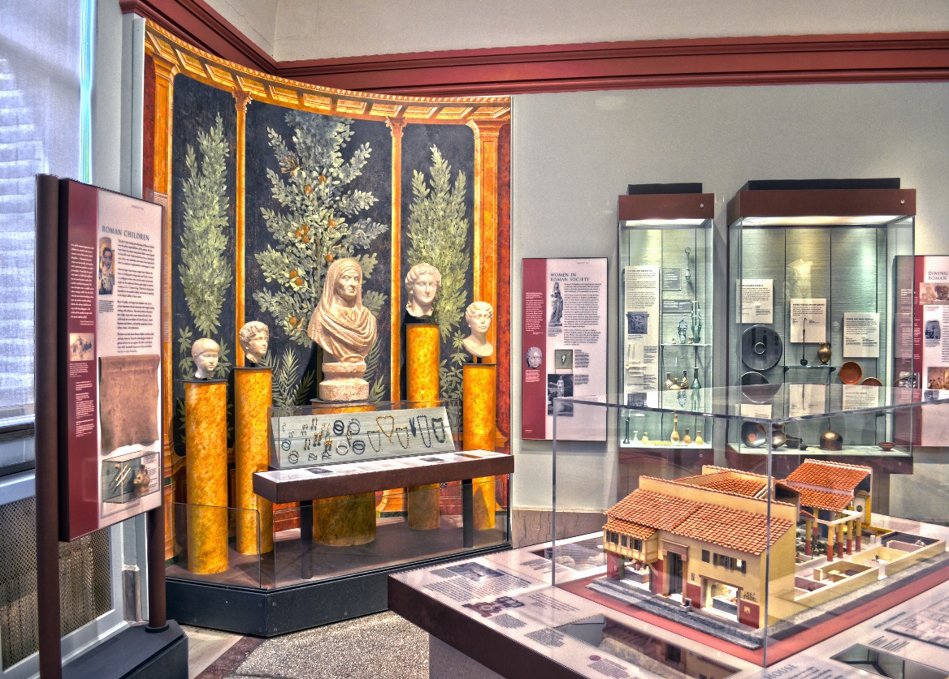 |  | At Home in Rome
Classical world: Roman Gallery |  | 50 minutes

This lesson is designed to help students become acquainted with vocabulary relating to topics such as the home, directions, and spatial relationships. Using objects in the Roman Gallery as visual inspiration, students will be able to put their new vocabulary to the test as they explore the exhibit and artifacts.

Vocabulary List

- Rooms/Spaces: kitchen, living room, bedroom, bathroom, hallway, doorway, porch, basement, dining room, garden, backyard, pool, courtyard, shrine
- Household items: cabinets, door, window, table, chair, sofa, bed, lamp, light, plants, statue, rug, tile, floor, ceiling, jar, vase, stairs, door knocker, pillow, plate, bowl, spoon
- Spatial relationships: left, right, straight, behind, next to, in front of, near, adjacent to, above, below, inside, outside, between, on top of, between, across, against, inside
- Materials: stone, glass, tile, ceramic, wood, cloth, bronze, gold, silver, plaster, cement, terracotta, marble
- Comparisons: larger, smaller, more, less, closer, farther

Pre-Visit Activities

Discussion Questions
- Write a paragraph describing your favorite room in your house. Where is it located? What other rooms are nearby? What items are kept in the room?
- Draw a floor plan of your house, labeling each room, as well as two items present in each room.

The Museum Visit

Explore
Give the class a few minutes to peruse the exhibit. Have them pay particular attention to the Roman house model and the household objects nearby.

House-model discussion
Gather students around the Roman house model and compare and contrast some of the differences between Roman houses and homes today.
- How does the layout of the Roman home compare to the layout of modern houses today?
- Are the rooms and items in the Roman home similar to ones found in houses today?
- Where in a Roman home might other artifacts in the exhibit be found? For example, where might a statue be located? Or a glass spice jar?
- Are the utility systems similar to what we use today, such as the lighting and water technology?

recommended objects

Model of a Roman House
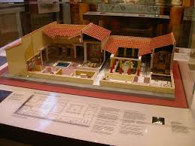

Mosaic (L-64-520)

Terracota Lamp (L-64-237)

Jug (E7512)

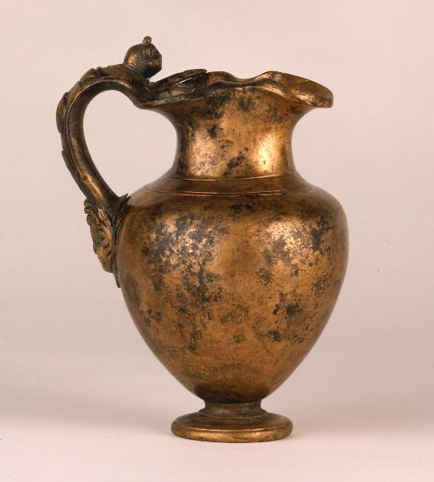

Red-gloss plate (L-64-448)

Bronze Lamp (MS2120)

Spice Jar (MS4933A)

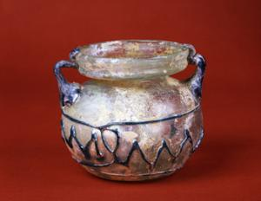

Post-Visit Activities

Real estate agent
Have students individually prepare a real estate ad for a home. Using the vocabulary from the lesson, students should describe some of the features of the home such as how many bedrooms the house has, if there is a garden, and so on. The goal is to market the home in an appealing manner while utilizing new vocabulary.

Creating a blueprint
Have students break off into pairs. Each student will sketch a blueprint of a 4-6 room house without showing the other (it does not need to be a large home). Then, without sharing her sketch, Student A will describe her blueprint to Student B. Student B will try to follow the directions of Student A in order to successfully reproduce Student A’s blueprint. Next, Student B will describe his blueprint to Student A, who will try to draw it from the description. The students can then compare the ‘originals’ with the copies and see how well they communicated their house design.

Questions?
Ready to schedule a visit?
Contact Penn Museum’s Academic Engagement Department at
classuse@pennmuseum.org

recommended objects

Strainer Spoon (L-1033-54)

Water Flask (MS4946)

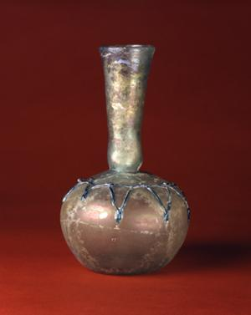

Wine Jug (86-35-67)

Oil Flask (MS4967)

Faun with Wineskin (MS3452)
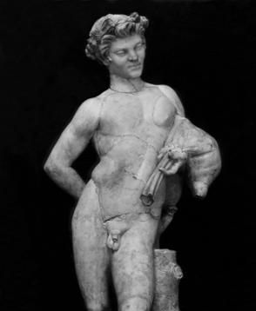

Herm Statue (32-36-68)

Ladle (E7142)

